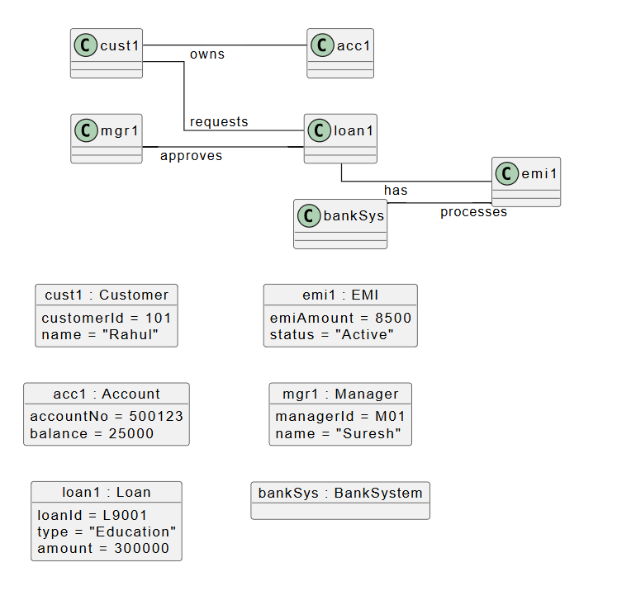
Object Diagram: Automated Banking System
System Name:
Automated Banking System

Objects:
- Customer
- Account
- Loan
- EMI
- Manager
- Bank System

Brief Description:
The object diagram of the Automated Banking System represents a snapshot of the system at a specific moment in time. It shows the real instances of objects such as customer, account, loan, EMI, manager, and bank system, along with their relationships during system execution.

Object Descriptions:
1. Customer Object
Object: cust1 : Customer
Description:
Represents a customer who uses the banking system to maintain an account and apply for loans.

2. Account Object
Object: acc1 : Account
Description:
Represents the bank account owned by the customer. It stores account details such as account number and balance.

3. Loan Object
Object: loan1 : Loan
Description:
Represents a loan requested by the customer. It contains information such as loan type and loan amount.

4. EMI Object
Object: emi1 : EMI
Description:
Represents the equated monthly installment associated with the loan. It manages EMI amount and repayment status.

5. Manager Object
Object: mgr1 : Manager
Description:
Represents the bank manager who approves or rejects loan requests.

6. Bank System Object
Object: bankSys : BankSystem
Description:
Represents the automated banking system that processes EMI calculation and EMI deduction.

Conclusion:
The object diagram provides a clear view of how different objects of the Automated Banking System interact at runtime. It helps in understanding the system behavior by showing real instances and their relationships.

